
A10
Sreenidhi Institute of Science and Technology
(An Autonomous Institution)
Code No: 101ME14/111ME14
B. TECH. III-Year I-Semester Examinations, December 2015 (Supplementary)
DYNAMICS OF MACHINERY (ME)

Time: 3 Hours Max. Marks: 70

Note: No additional answer sheets will be provided.

Part - A
Max.Marks:20

Answer all QUESTIONS. EACH QUESTION CARRIES 2 MARKS.
1. Define film lubrication state and its laws.
2. What is meant by a "self locking" and a "self-energized" brake.
3. What is processional motion? What is meant by applied gyroscopic torque and reaction gyroscopic torque.
4. Define static force analysis with a suitable example.
5. Explain uses of turning moment diagram.
- Define the terms i) Governor height and ii) Equilibrium of Governor
- Describe reasons in detail for partial balancing of reciprocating masses.
- How is effect of hammer blow reduced in coupled locomotives?
- State the expression for logarithmic decrement in damped vibration
- Explain briefly the phenomenon of the whirling of shafts.
Part – B
Max.Marks:50
ANSWER ANY FIVE QUESTIONS. EACH QUESTION CARRIES 10 MARKS.
- a) Derive the expression for friction torque by using uniform wear theory for a flat collar.

b) The shaft of a collar thrust bearing rotates at 200 rpm and carries an end thrust of 10 tonnes. The outer and the inner diameters of the bearing are 480mm and 280 mm respectively. If the power lost in friction is not to exceed 8 kW, find the co-efficient of friction of lubricant of the bearing.

2. The turbine rotor of a ship weighs 6 tonnes and has a radius of gyration 600mm. It rotates at 1800 rpm clockwise when viewed from front. Determine the gyroscopic effect.
a) If the ship travelling at 1860 m/hour and when it streers to the right in a curvature of 100 m radius.
b) If the ship pitches with 10 rad/s angular velocity and when nose moves down.
c) If the ship is rolling and at a certain instant has an angular velocity of 0.02 rod/s in clockwise direction looking from stern.

- A single cylinder single acting four stroke gas engine develops 20kW at 300 rpm. The work done by the gases during the expansion stroke is three times the work done on the gases during the compression stroke, the work done during the suction and exhaust strokes being negligible. If the total fluctuation of speed is not to be exceed ± 2% of the mean speed and the turning moment diagram during compression and expansion is assumed to be triangular in shape, find the moment of inertia of the flywheel.

- A governor of the Hartnell type has ball arm and sleeve arm of lengths 125mm and 62.5mm respectively; the fulcrum of the bell crank lever being 100mm away from spindle axis. The governor runs at a mean speed of 300rpm, each ball has a mass of 2.3kg, and a 3 percent reduction in speed causes a sleeve movement of 6mm. If the ball-arm is vertical at the mean speed, and gravitational effects are ignored, find the spring stiffness in N/m. Neglect the mass of the arms. By how much must the adjusting nut be screwed down to render the governor isochronous and what will be the resulting operational speed of the governor?
- Four masses A, B, C and D are completely balanced Masses C and D make angles of 90º and 195º respectively with that of mass B in the counter-clockwise direction. The rotating masses have the following properties:
Mass of B=25kg, Mass of C=40kg, Mass of D=35kg
Radii of A, B, C and D are 150mm, 200mm, 100mm, 180mm respectively
Planes B and C are 250mm apart. Determine the
Mass A and its angular position with that of mass B
Positions of all the planes relative to plane of mass A

- a) A vibrating system consists of a mass of 50kg, a spring with a stiffness of 30 KN/m and a damper. The damping provided is only 20% of the critical value.Determine the i) damping factor ii)critical damping coefficient iii) natural frequency of damped vibrations iv)logarithmic decrement v)ratio of two consecutive amplitudes.

b) A shaft of 40mm diameter and 2.5m length has a mass of 15kg per meter length. It is simply supported at the ends and carries three masses of 90kg, 140kg and 60kg at 0.8m, 1.5m and 2m respectively from the left support. Taking E=200GN/m2,
Find the frequency of the transverse vibrations.

- a) Explain the working of a belt transmission dynamo meter.

b) The band brake shown in figure below is applied to a shaft carrying a fly wheel of mass 300 kg with a radius of gyration of 400 mm and running at 340 rpm. Find torque applied due to a pull of 100N if μ=0.25. Also find the number of revolutions of the fly wheel before it comes to rest.
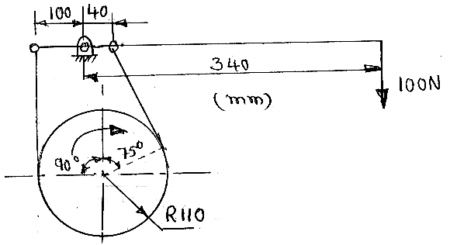

- a) Derive the expression for logarithmic decrement.
b) The free vibration decay curve for a spring mass damper system is shown in below figure. If the mass of the system is 10kg. Determine the damping coefficient and the spring stiffness.
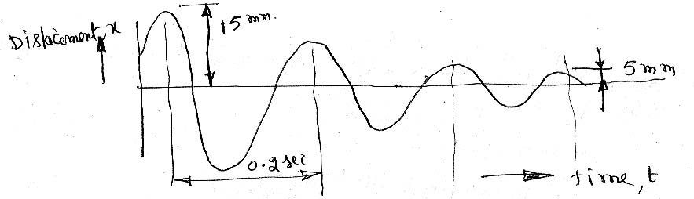

-- 00 -- 00 –

